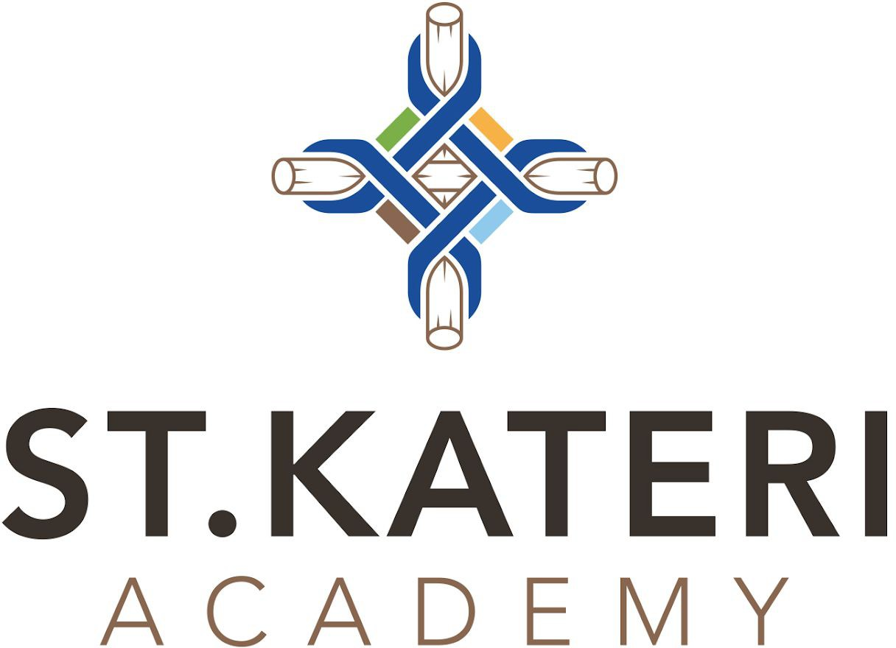

SKT Hockey Program

Offered through St. Albert Sports Academy Sports Academy Programming (Hockey):
- Two 1 hour ice sessions each week from September - March
- On Ice sessions will include technical skill development, specialty coaches and tactical concepts
- Small area skill development to enhance players skills and game understanding
- April - June: additional excursions that compliment hockey specific dryland training and additional athletic activities (i.e. wall climbing)
- Cost Estimated @ $1350.00/school year. The fee would be $135.00/month for 10 school months
- Cost will include student transportation
- Offered by the St. Albert Sports Academy
- Ice time requested Tuesday and Thursday mornings from 8:15 - 9:15 A.M.

