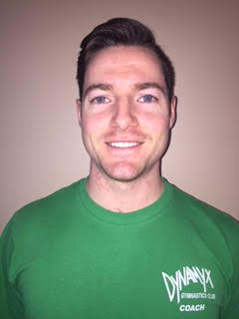

KEEGAN FARRELL
Gymnastics Coach
Dynamyx Gymnastics Club
BIO
Certifications:
Level 2 Men’s and Women’s Artistic Gymnastics
Level 2 Trampoline Trained
Standard First Aid CPR/AED Level C Certified
Respect-in-Sport Certified
Personal Fitness Trained - CanFit Pro - Part A
NCCP Senior Soccer Qualified
Coaching Experience:
-7 Years of Full-time gymnastics Coaching
-10 Years of Competitive Soccer Coaching

