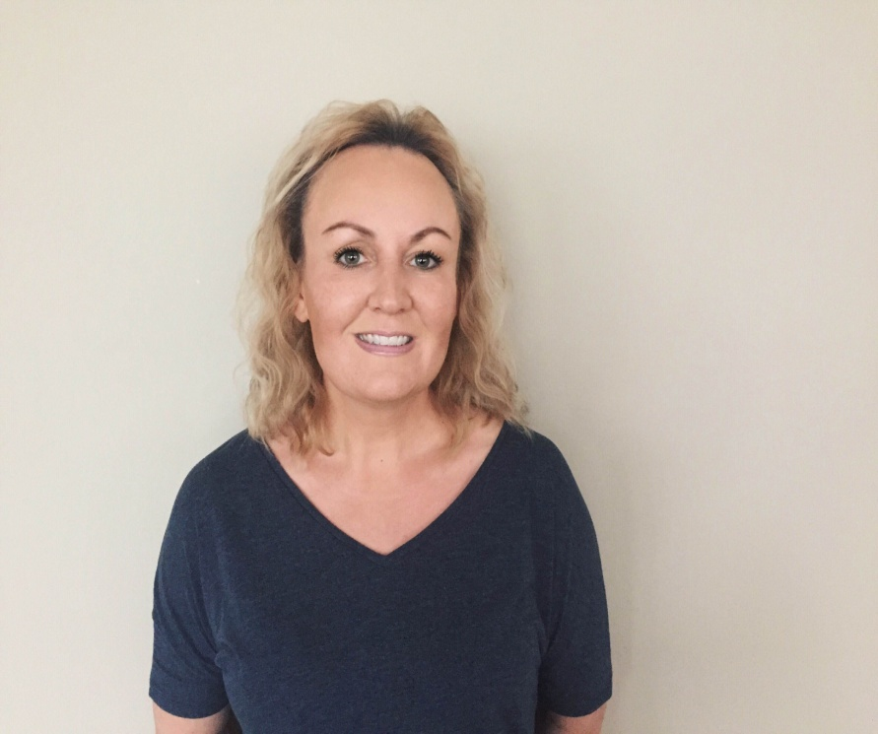

SHANNON KRULL
Gymnastics Coach
Dynamyx Gymnastics Club

Bio

- NAIT Office Administration Graduate
- Certified Level 2 Gymnastics Coach – Women’s Artistic
- Level 1 Cheer Coach
- Level 1 Trampoline Coach
- Level 1 Rebound Therapy Trainer
- Active Start Coach (Children under 6 years of age)
- Junior Olympic Choreography Clinic
- Babynastics – Trained
- Nonviolent Crisis Intervention – Trained
- Entering my 9th year of coaching

